UW Animation Capstone, VR
Unity 2018.1 Post-Processing and Shading Graph
Demoed by Natalie Burke, March 29, 2018

Disclaimer: Links ARE NOT up to date with 2018.1. Please only use as general reference. Images are from 2018.1b13
- Set up the project (choose one of the below)
To create a new VR project starting in Unity 2018.
  - Create new project. Several new templates were added in 2018. Use “Lightweight RP for VR”
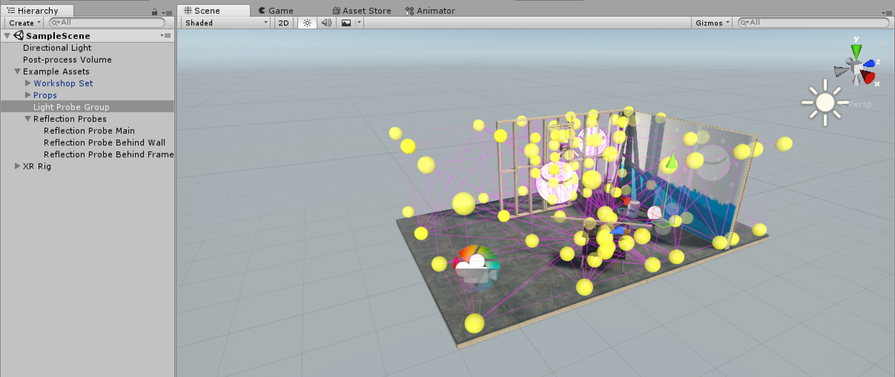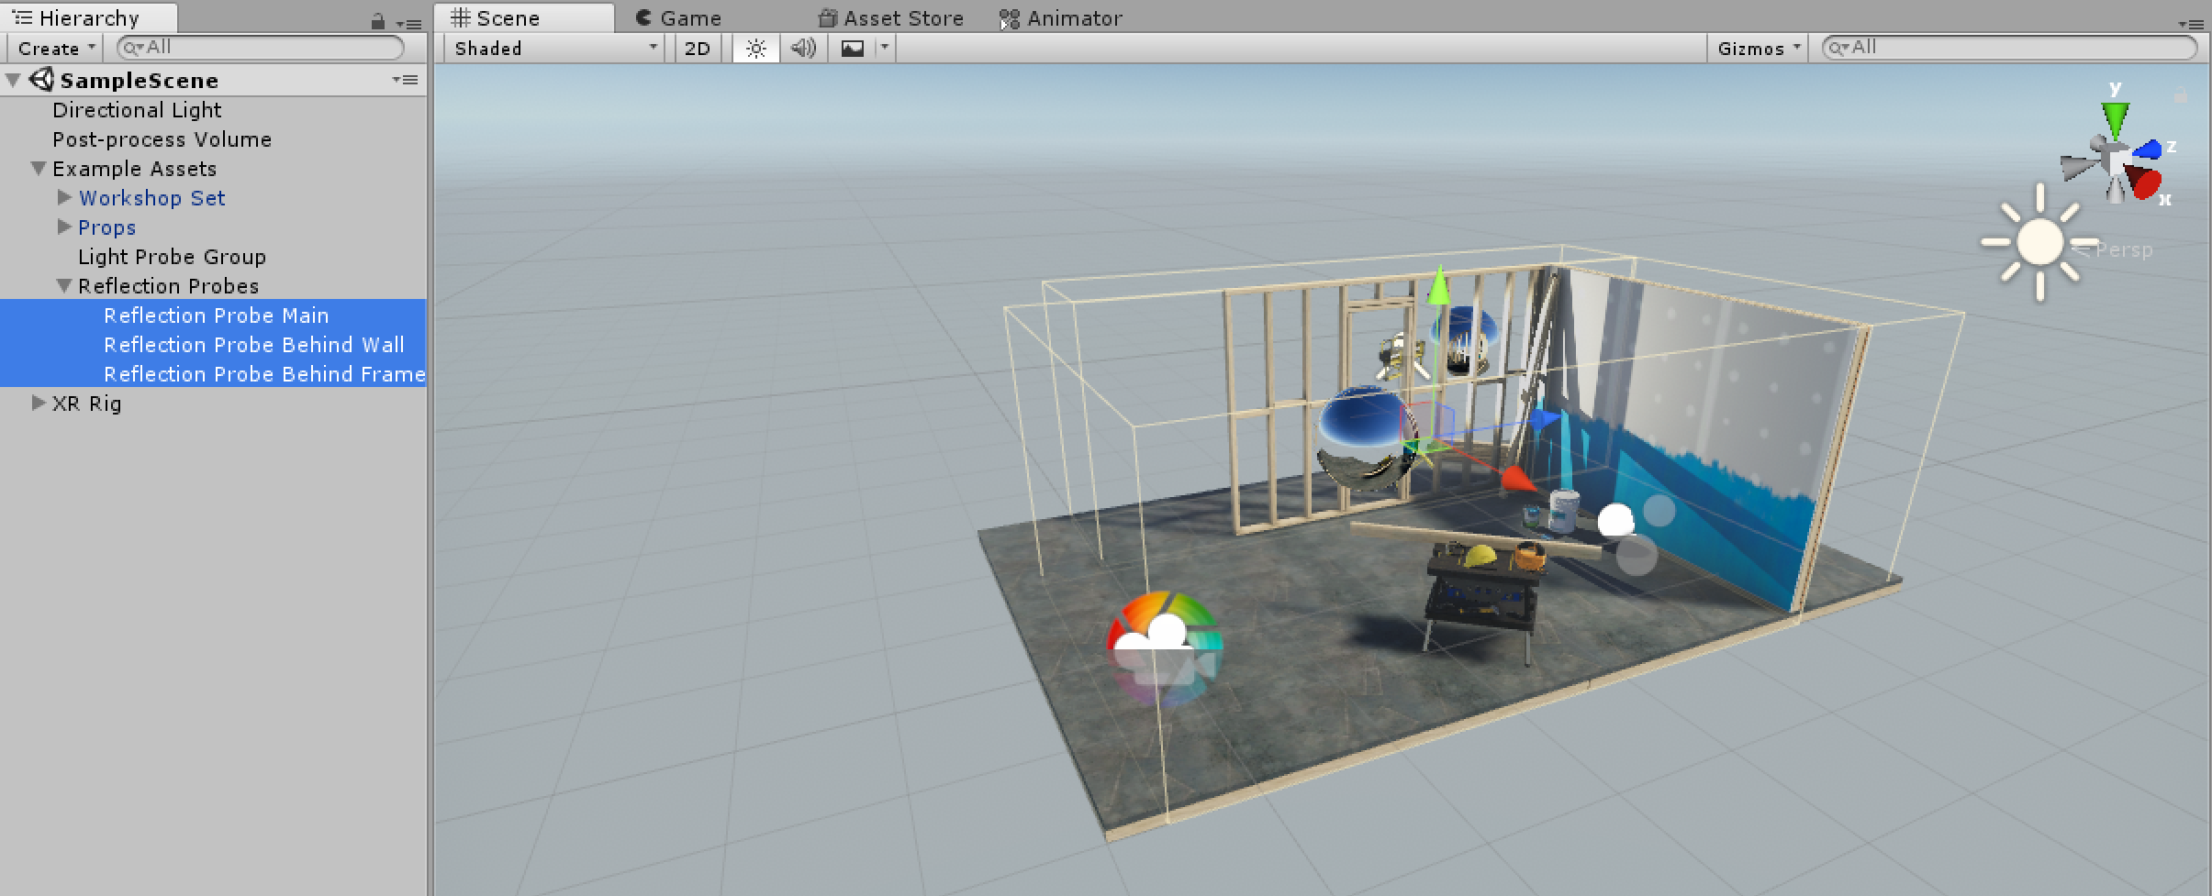
(Scenes come with example content, including a light probe setup (left, generates indirect light data based on probes) and post-process volumes (right, has presets with texture import and audio settings, if using the VR template will include settings tuned for VR)
To update to 2018.1 from old Unity version
  - Install lightweight render pipeline
    - Open package manager: window > package manager
    - Render-pipelines.lightweight install
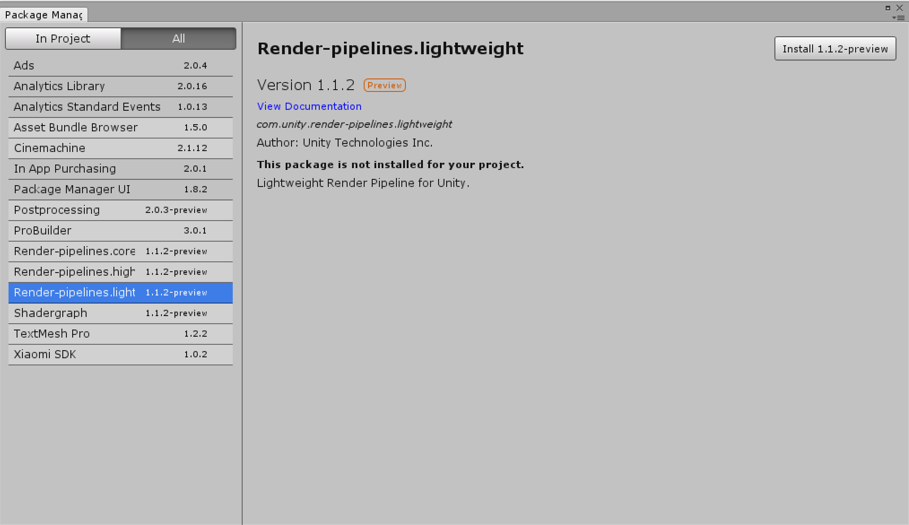
  - Change rendering to lightweight
    - Open settings folder (create one if it doesn’t exist) and right click: create > rendering > lightweight pipeline asset. This should create a LightweightAsset

    - Edit > project settings > graphics. In the inspector, make sure the Scriptable Render Pipeline Settings is set to the new LightweightAsset. Everything should turn pink
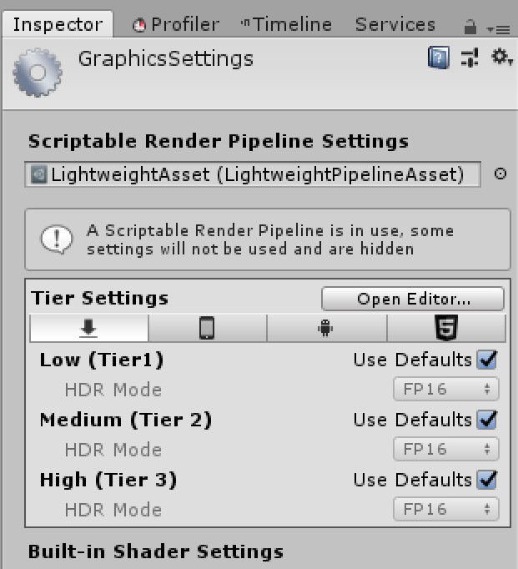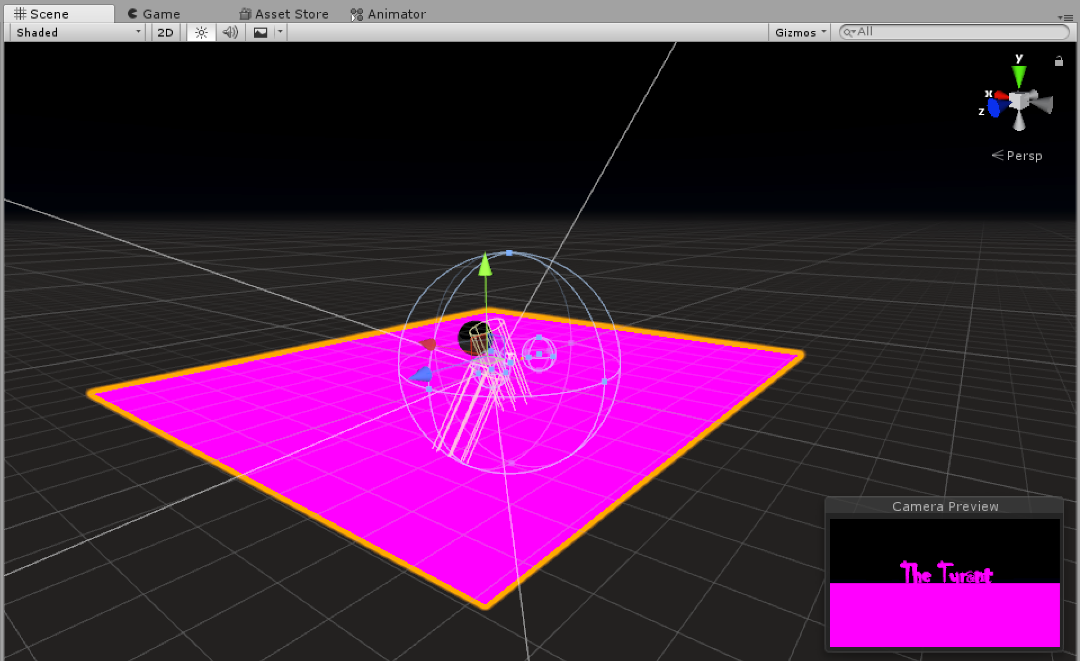
    - Select all materials in the scene (click and drag over the scene). Edit > render pipeline > upgrade selected materials to lightweight. Click proceed.
  - Change light render modes. Only one light (the main shadow light, usually a directional one) should be real-time, all others should be baked.
    - To change render mode, click on the light. In the inspector, change the mode to baked
- Setting up initial post-processing.
Overview: https://docs.unity3d.com/2018.1/Documentation/Manual/PostProcessingOverview.html
  - Create post-processing volume (artist-placeable zones with automated transitions)
    - Create asset: create > 3d object > post-processing volume
    - Camera needs to be physically inside the post-process volume to work (Ctrl-shift-f to move camera)
  - Set post-processing layers for volumes (https://docs.unity3d.com/2018.1/Documentation/Manual/Layers.html)
    - Click on post-processing volume. In the inspector, click on the “layers” dropdown and click “create new”
    - Add “post-processing” layer
    - Go back to the inspector for the post-processing volume. Make sure the “layers” dropdown is set to “post-processing.” Repeat for all such volumes
  - Set post-processing layers for cameras (https://docs.unity3d.com/2018.1/Documentation/Manual/PostProcessing-Stack-SetUp.html)
    - Click on the camera object. Click on “add component” and add a post-processing component.
    - Make sure post-processing component has the same tag as the volumes (“post-processing”)
  - Set overrides for post-processing volumes (recommended ones for VR below)
    - Color grading (altering the color luminescence - https://docs.unity3d.com/2018.1/Documentation/Manual/PostProcessing-ColorGrading.html). Make sure mode is set to ASCC.
    - Bloom (simulates image artifacts, e.g. a bright light - https://docs.unity3d.com/2018.1/Documentation/Manual/PostProcessing-Bloom.html)
    - Auto-exposure (to account for eye adjustment for light setup)
    - Vignette (darkening of the edges - https://docs.unity3d.com/2018.1/Documentation/Manual/PostProcessing-Vignette.html)
  - Overrides to AVOID for VR
    - Depth-of-field (https://docs.unity3d.com/2018.1/Documentation/Manual/PostProcessing-DepthOfField.html) – render times, doesn’t work too well for VR
    - Grain (https://docs.unity3d.com/2018.1/Documentation/Manual/PostProcessing-Grain.html) - want to be HD as possible for VR
    - Motion blur (https://docs.unity3d.com/2018.1/Documentation/Manual/PostProcessing-MotionBlur.html ) - finicky for VR
    - Screen-space reflections (https://docs.unity3d.com/2018.1/Documentation/Manual/PostProcessing-ScreenSpaceReflection.html) - because of render times
- Setting up shading graph
  - Create PBR graph
    - Create new shading graph (in assets, right click, create > shading > PBR graph)
    - What it should look like initially:
  - Create nodes
    - Right click > create node > create node
    - Checkerboard node example below:
- General notes for nodes
  - Textures: Can click and drag from the folders into shader graph
  - Color of wires indicate the type, change in color indicates type change, e.g. a 4-vector to 3-vector
  - Normal nodes: the type will be “normal,” rather than default
  - Preview node can be used to preview attributes
- Attaching shading nodes to an asset
  - Create material
  - Click and drag node editor (?)
- Using the Blackboard (Can create properties and animate values to them)
  - Click plus sign to create property and set name
  - Set values
- Propagating texture to materials
  - Select all nodes, right click, and convert to subgraph. This creates one node for everything (double click to enter a copy of the original graph)
  - Attach as property in the inspector

